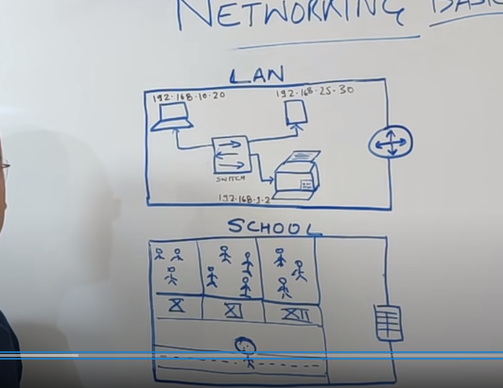

IP: identify the unique address and specific the laptop

Switch: like ekta LAN er moddee ekta computer thekay print korbay then oi computer command dibay ebong printer ti oi specific computer er jonnow print korbay ar ei LAN er moddee jogajog koray thakay switch. School er mode pion er je kaj ta thakay oi kaj ta koray thakay setai holo switch er kaj.

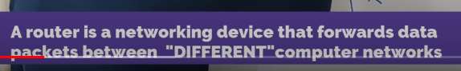

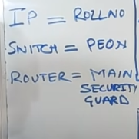 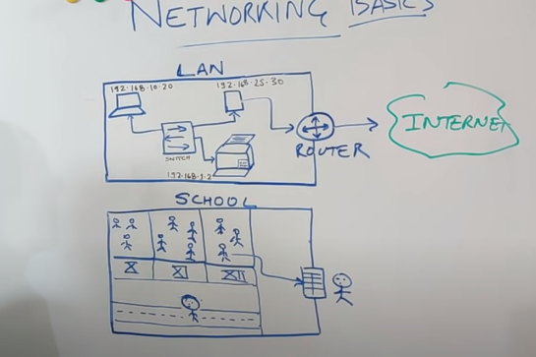

Router : Lan er bairay kono internet er sathay connect hotay chailay router use kortay hoi router er maddome LAN er bairer onnow computer er sathay communicate kora hoye thakay.

School er bairay jetay chailay gatekeeper er onumoti niye jaitay hoi ar ei gatekeeper ei holo router.

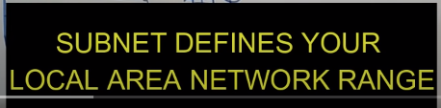

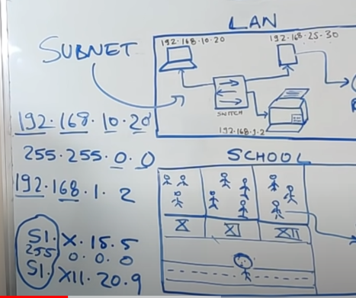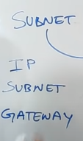

192.168. -🡪 defines the local area network then 10.20 ---🡪personal IP address.

GateWay: Routrer er IP address ta kai gateway bola hoye thakay. Any potential device need three things IP, Subnet, GateWay. Ekta LAN create kortay chailay ei tinta jinis lagbai.

WAN:

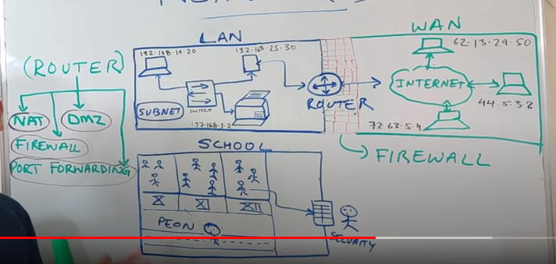

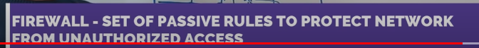

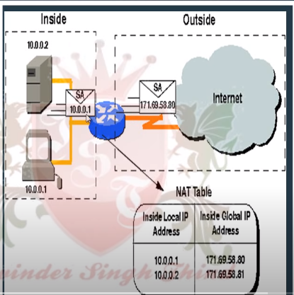

NAT converts Private IP address to real IP/Public IP address for accessing the internet

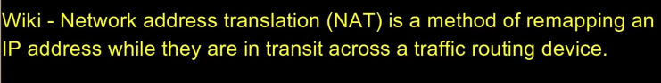

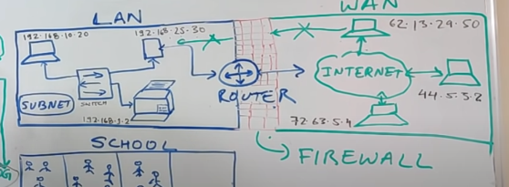

LAN er network er personal IP address er kew WAN er sathay directly connect thaktay parbay na, connect hotay holay FIREWALL er maddomme connect hobay security purpose er jonnow. Unauthorised er kew kay dhuktay dai na FIREWALL.

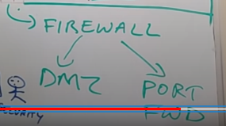

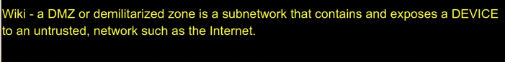

WAN Jodi connect hotay chai LAN er sathay tokhon WAN er request atfirst Router er kasay jai then router FIREWALL er moddee obosthito DMZ er kasay pathai jeno kono unauthorized kew access na pai.

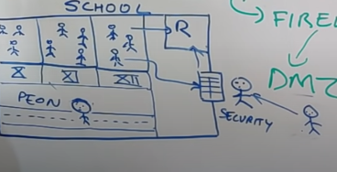

School er khetray boltay gelay kono parents Jodi student er sathay dekha kortay chai tokhon gateKepper er kasay onumoti nitay hoi then waiting room e wait koray oikhan e student essay parents ar student dekha koray thakay. Ar ei waiting room tai holo DMZ.

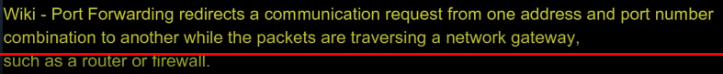

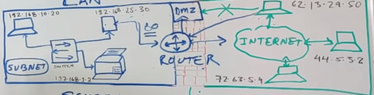

Ekti device onnow ekti device er sathay connect hotay chailay port er maddomee holay seta kay bola hoi PORT FWD . specific port number milay gelai then connect hoi ebong packet pathiye thakay.;

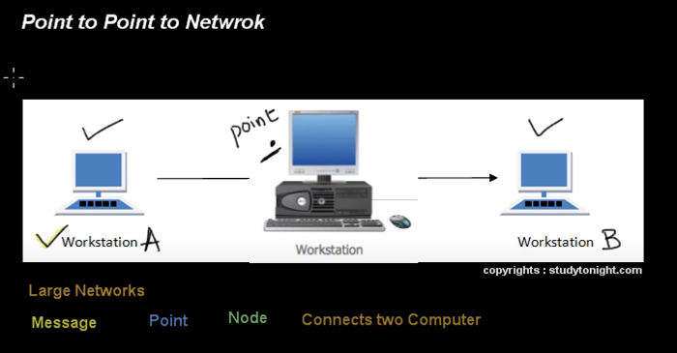

Ekta computer onnnow ekta computer er sathay connect korar jonnow dui computer er moddee point use koray thaki eta asolay large network er jonnow use koray thakay.

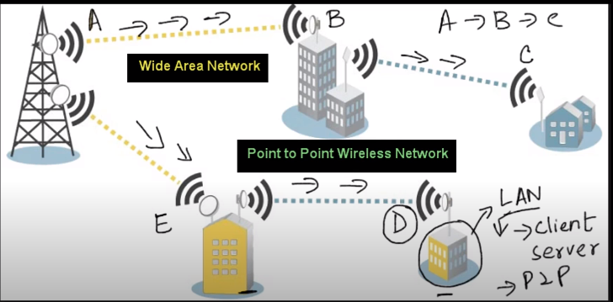

Point to point network e ekta path busy thaklay onnow path use kortay parau jar jonnow data fastly pathatay paray.

Topology: ekta network create kortay je component lagay(like computer, router, device,modem,wire) ei component gulu ekay oporer sathay kivabay join assay setakai network topology bolay.

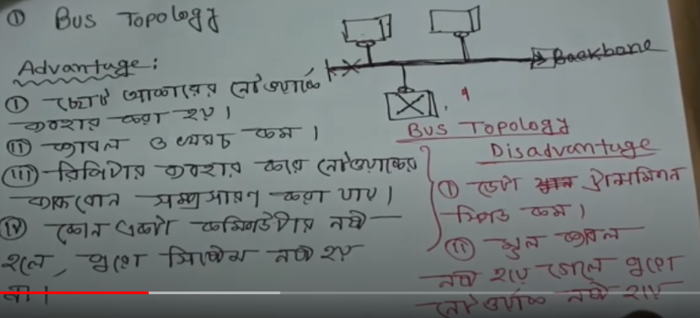

Ex: school, college, university er jekono ekta department hotay paray.

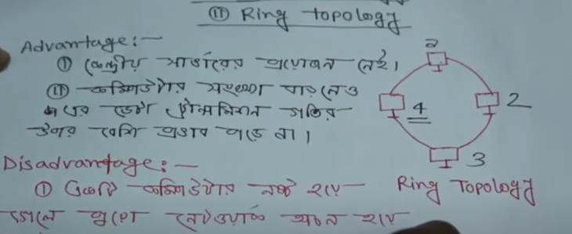

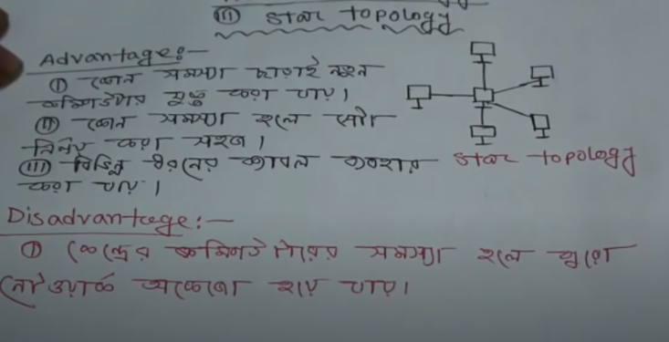

Ekta computer onnow ekta computer kay data pathatay chailay onek secure way tay pathano shombov. Sobgulu Pc independently thakay so ekti computer data specific koray onnow ekti compuer e pathano jai. Etay koray onnow kew ei data pabay na.

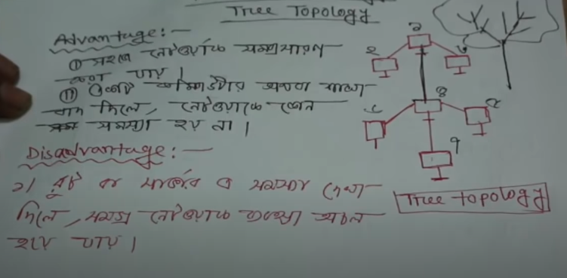

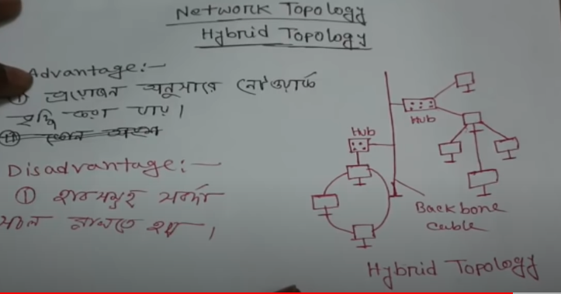

Real life e je network amra use koray thaki oigul sob e holo hybrid network. Proyojon onujayi amra ei network baratay komatay pari. Data onek secure hoye thakay

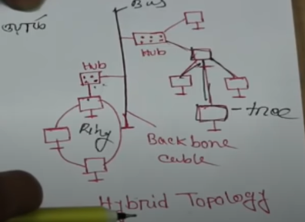

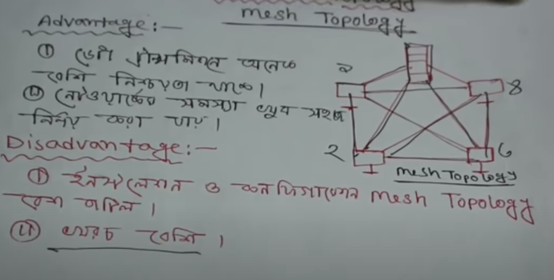

Secure way tay data pathano jai. Bivinnow banking sector e ei topology use koray thakay.

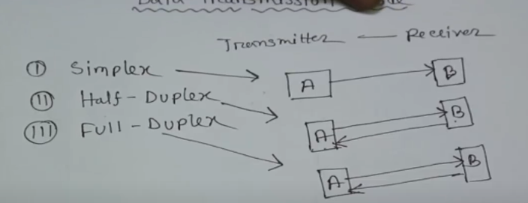

Simplex--- television, loudspeaker

Half-Duplex------ walkie-talkie

Full-Duplex-----mobile, telephone

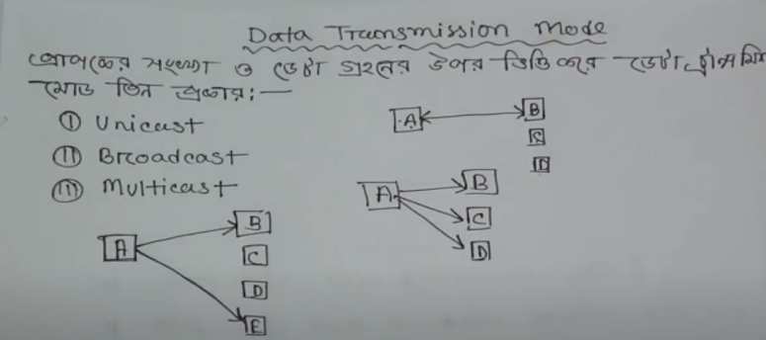

Unicast----like telephone or mobile e kotha bollay shudhu oi dui device er moddee communication hobay ar eita holo unicast.

Broadcast----- Like television e atnbangla ekta news publish korsay ar B,C,D ekoi somoy iota dekhtay parbay. Orthat A publish korbay ebong ekoi somoy sobai pabay.

Multicast-----Like eid er moddee ami msg korbay ekhon jakay khushi takay pathatay parbo. Esaraw video conference holo multicast communication.

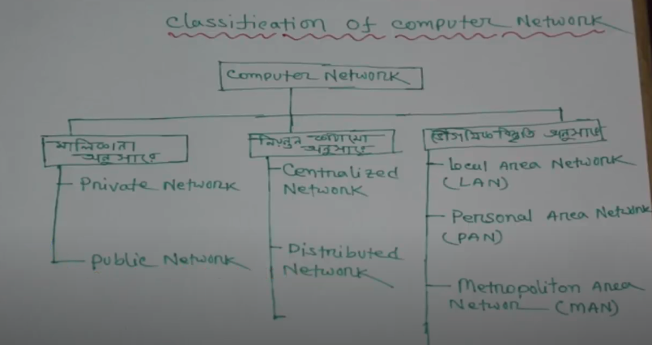

Public Network: sokolay access pabay. Data Transfer speed kom. Ek sathay onek e use kortay paray.

Private Network: sokolay access pabay na. Data Transfer speed besi. Ek sathay onek e use kortay paray na. Specific lokjon e use kortay parbay.

Centralized network: je network e ekta nirdisto niyontron thakbay takay Centralized network bolay. Orthat ekta pc othba ekta work station er maddome onek gula pc niyontron koray thakay.Ex. kiso din agaw amra cyber café tay giye net use kortam ar ekjon manus bosy thakto je kina dekhto ke kotokhon chalaschay net. Se chailay jekono network er net bondho koray ditay parto. Ar eta hoschay centralized network.

Distributed Network: je network e ekta nirdisto niyontron thakbay takay na borong onek gula niyontron thakay tokhon takay Distributed Network bolay. Orthat eker odhik pc othba eker odhik work station er maddome onek gula pc niyontron koray thakay.

Local Area Network( LAN): ekta specific area er moddee eti kaj koray thakay. Like 100 mitre or 200 metre er moddee kaj koray thakay er bairer kaj koray thakay na. EX. School, College, je kono ekta building.

Personal Area Network(PAN): ekta specific area er moddee eti kaj koray thakay. Like 10 mitre or 20 metre er moddee kaj koray thakay er bairer kaj koray thakay na. EX amader basai je network use koray thaki oita holo PAN jekhanay 2 or 3 ta PC kaj koray thakay.

Metropolitan Area Network(MAN): eita ekto boro dhoroner network jekhany onek pc connect thakbay. Metro boltay ekta boro city kay buzano hoye thakay. Like Dhaka ekti metropolitan city. Ekhon full dhakay kay ekta network er awtai antay chailay seta hobay MAN.

Wide Area Network(WAN): jekhanay onek boro ekta network kaj koray thakay. Like bangaldesh kay ekta network er awtai antay chassi taholay seta hobay WAN. Echaraw shudhu ekta desh hotay hobay emon na ekhanay onek gula desh hotay paray . Like grameen phone, Robi eigula pura Bangladesh kay cover korray thaky tai eti holo WAN. Echaraw amra je EMO, WhatsApp Use koray thaki jar sahajajay amra pura world er satahay communicate kortay pari etio holo WAN.

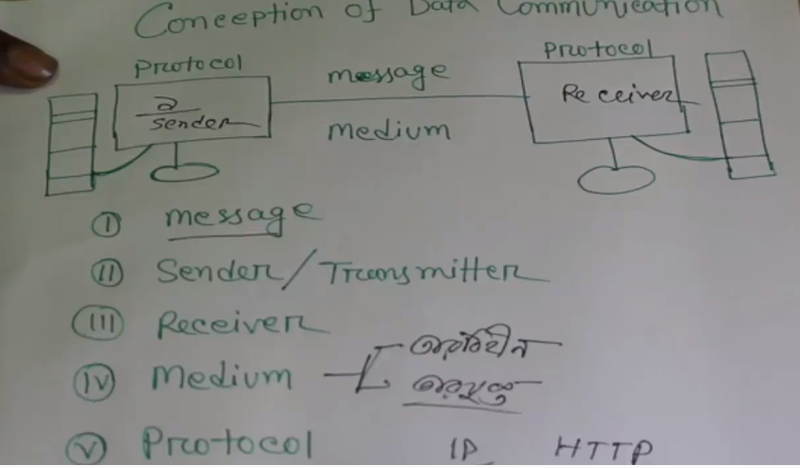

Protocol: Sender thekay recever er kasay kono message pathaitay chailay kiso rules maintain kortay hoi ei rules ei holo protocol.

Parallel transmission: ekoi songey onek gula data pathano jai. Ex: computer e usb port parallel transmission hoy. Duroborti kono jaigai data pathatay chailay parallel ei data pathano hoi na. data delay hoi,

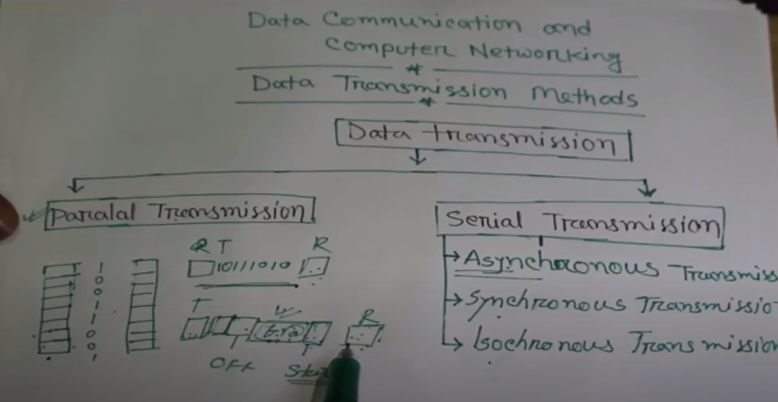

Asynchronous Transmission: ei transmission er maddome amra 8 ti bit data ekoi sathay pathatay pari. Tobay data pathanor agay ekti start bit ebong 1 ti or 2 ti off bit pathatay hoi. Ei transmission e data druto patahano jai na. tobay data pathanor khetray eder majay kono storage er projon poray na. Ex: computer thekay printer e data pathano, keyboard thekay CPU tay data pathano ei Asynchronoys method e pathano hoi. Tobay ei transmission e 8 bit er besi data pathano jai na.

Synchronous Transmission: ei transmission er maddome amra 80-132 ti bit data ekoi sathay pathatay pari. Eikhanay start bit ebong off bit pathaitay hoi na. kinto time signal pathaitay hoi. Data druto pathano jai. Ei transmission e primary storage er proyojon poray data pathanor khetray. Ei transmission ekto baibohol. Er circuit board ekto jotil hoye tahkay. Data gulu packet akaray pathano hoi.

Isochronous Transmission: ei transmission ti holo Synchronous transmission er update version. Jettay asolay block akaray data pathano hoi. Synchronous way tay data pathailay ekta block data sender thekay recever e gelay ekto time niye then aber ar ekta packet jai kinto Isochronous way tay ei time er proyojon poray na. without mili second e data recever e powsai. Time delay hoi na ei method e.

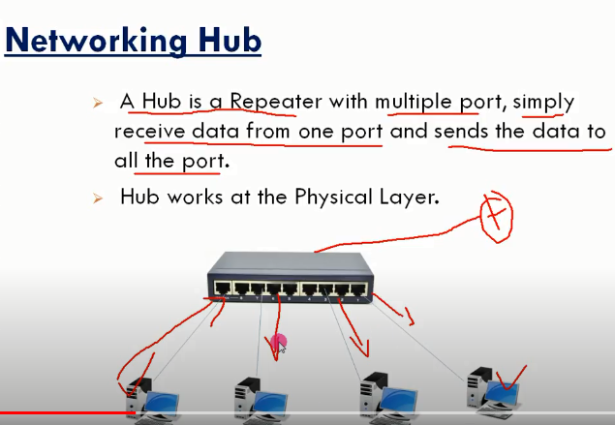

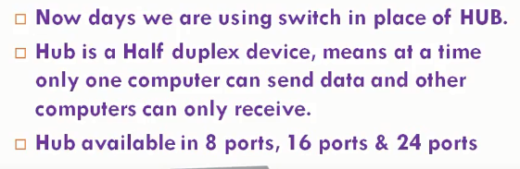

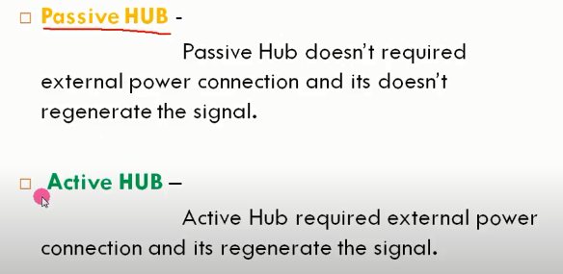

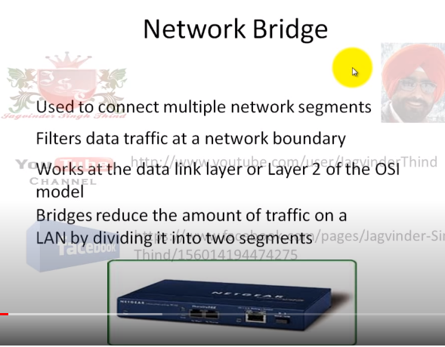

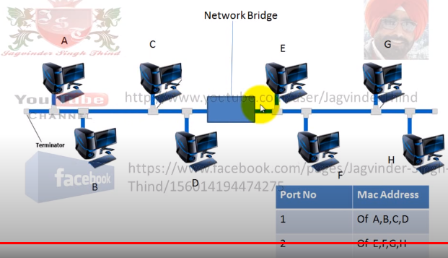

Like A data send korbay D kay taholay data ta B,C,D tay khali broadcast hobay karon bridge check korbay D kon port e assay Ist port e thakai port 2 tay data broadcast korbay na. orthat ordek traffic koay gelo. Aber A Jodi G kay data pathaitay chai tokhon aber bridge er kasay data aslay check korbay G kon port e assay jeheto Port B tay assay so Port 2 tay data pathiye dibay. G data peye jabay baki gula data ta kay discard korbay karon data ta Only G kay paron korsay. Ar evabay Bridge kaj koray thakay.

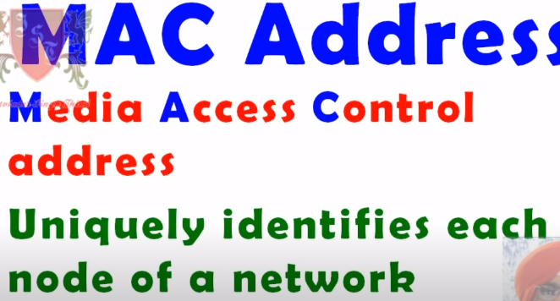 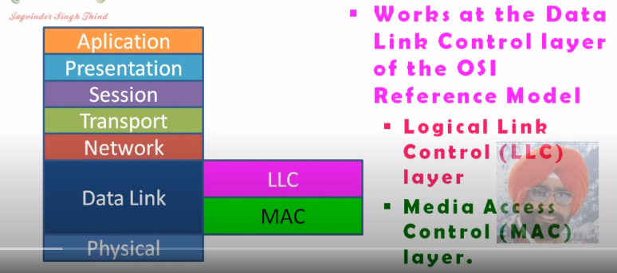

Also Called

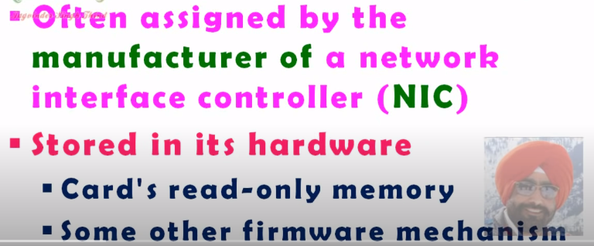 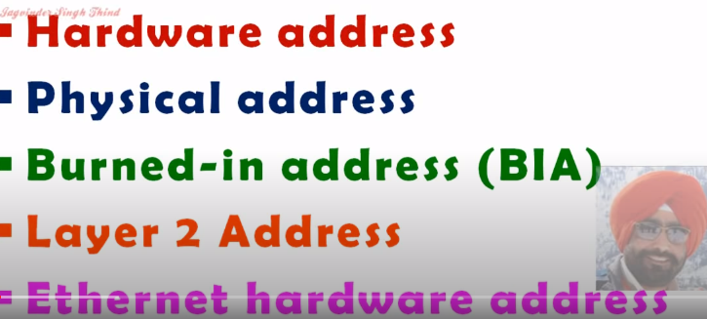

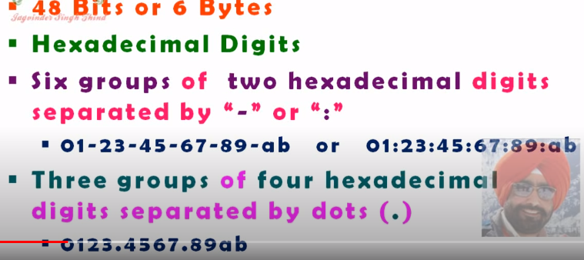 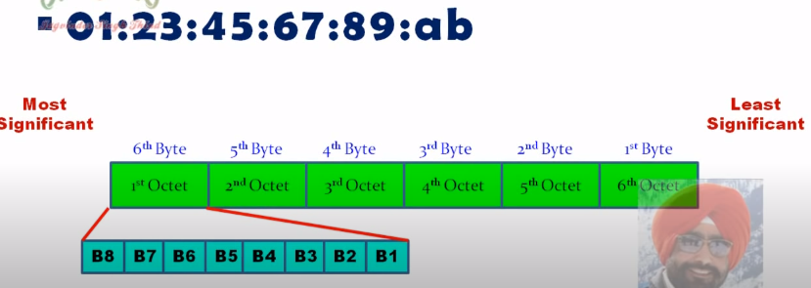

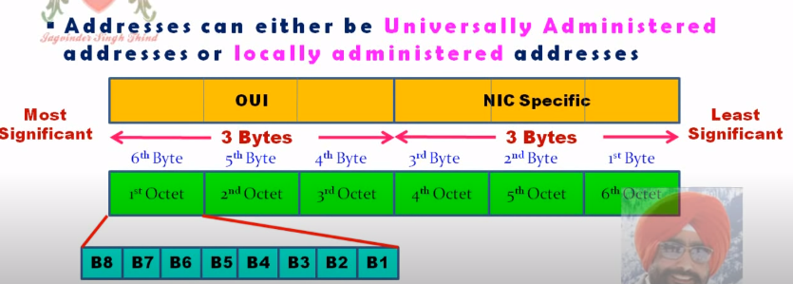

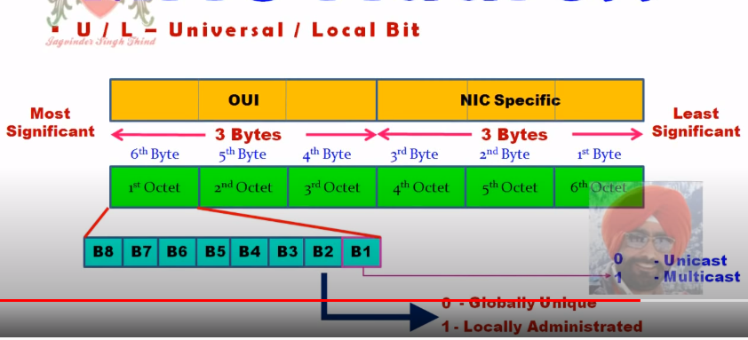

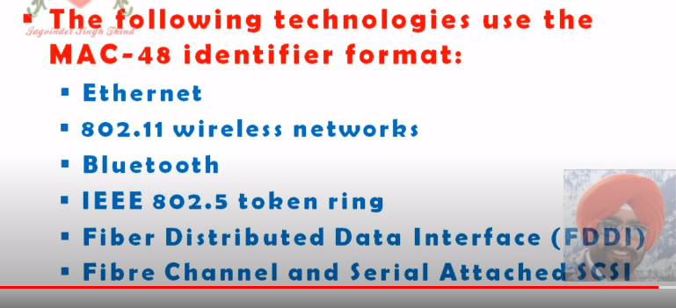

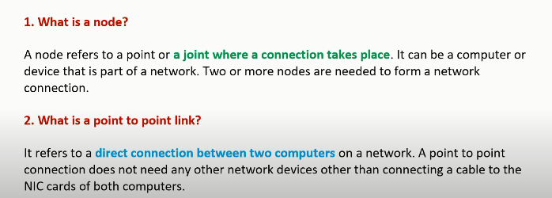

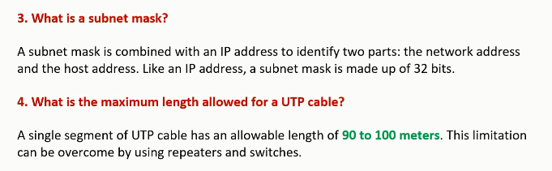

Subnet mask: identify the network and host part.

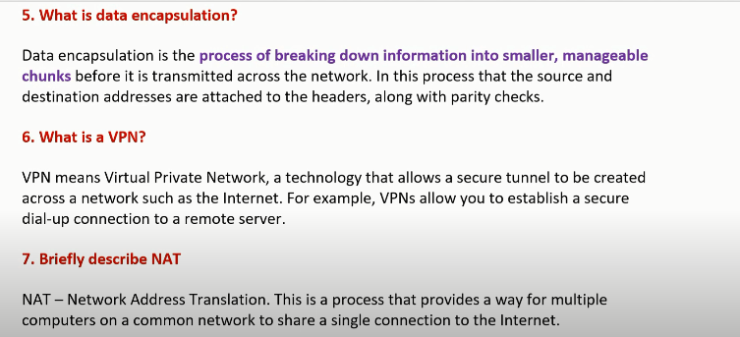

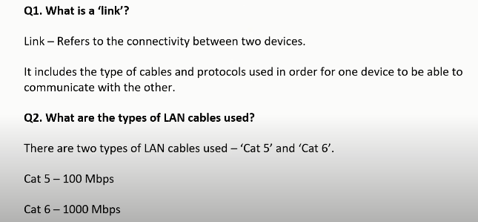

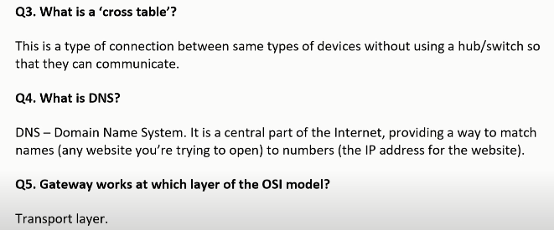

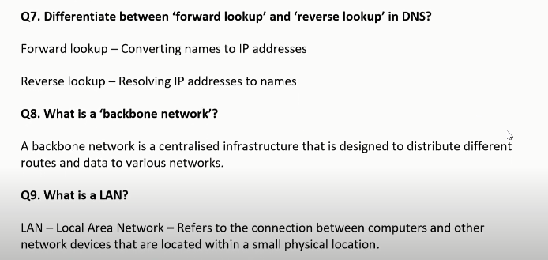

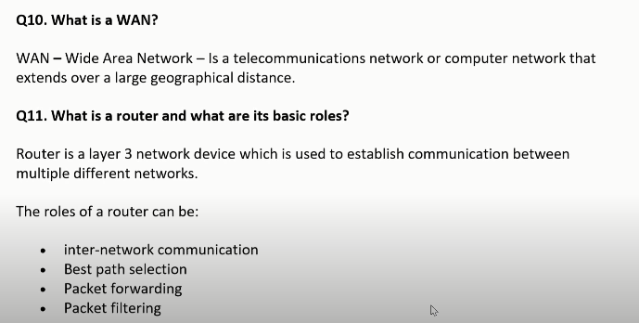

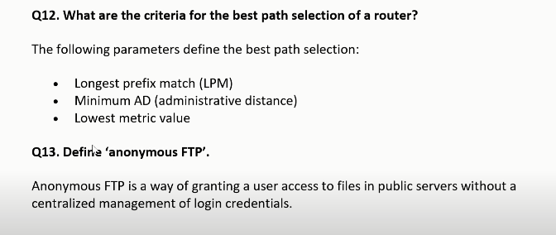

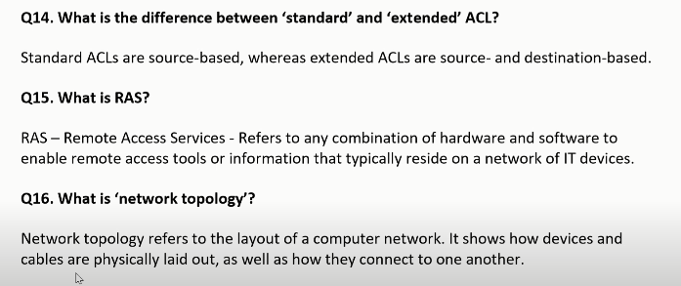

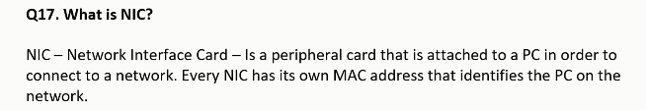

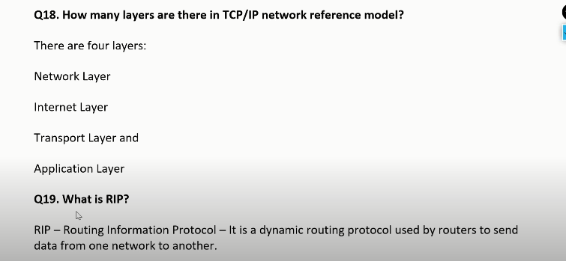

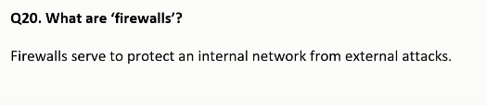



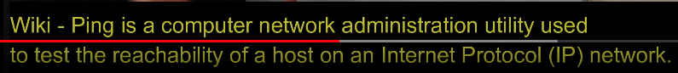



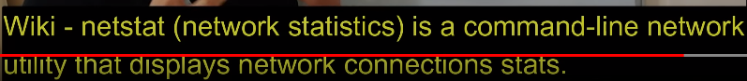

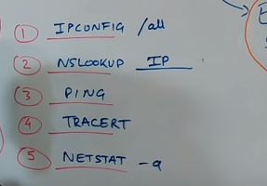

Routing: like S thekay data D tay pathabay ekhon atfirst Source ekata path choose koray orthat optimal path choose koray destination D tay pathabay. Ar eta holo routing. Source and Destination alada network e assay. Tobay Protomay R1 er kasay routing table assay jar sahajjay Destination e data jabay. Orthat particular ekta route use koray msg ti send korbay.

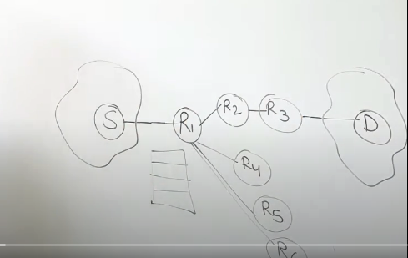

Flooding: Source thekay data send korlay R1 janay na kon routing use korbay tai R1 thekay tar parsoborti sob router kay data diye dibay orthat sobaikay msg send korbay Karon R1 er kasay kono routing table nai tai sobar kasay pathiye dibay are tai holo flooding.

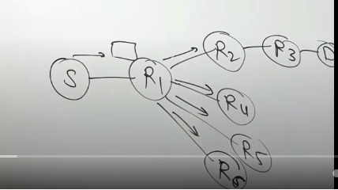

RT- Routing Table

Reliability less in routing because Jodi routing path ta Jodi kono karonay off thakay taholay packet ar pathatay parbay na . kinto flooding holay kono na kono path use koray thik e packet pathye dibay. Only ekta path use koray thakay tai traffic less hoye thakay ar flooding e onekgula path use koray thakay tai er traffic high hobay.

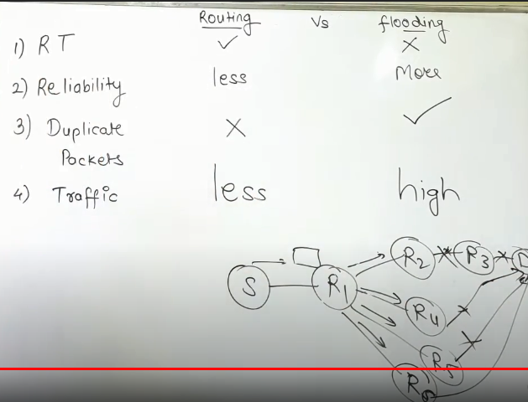

What is a Gateway?

A gateway interconnecting networks above the network layer is the most complex network interconnection device. It is used only for interconnection of different networks between two high-level protocols. The Gateways can be used for both WAN and LAN interconnects.

A gateway is a computer system or device that serves as a transitional task. The gateway is a translator between two systems that use different communication protocols, data formats or languages, or even completely different architectures. Unlike the bridges, which simply convey information, the Gateways repackage the information they receive to suit the needs of the destination system.

How does the Gateway work?

We can take an example.

There is a boy, named Tom (Data). Tom lives in one room of an apartment. There are many friends in other rooms. Tom’s parents are the Gateway. If Tom want to play with one friend, he needs to shout friend’s name in the room. If his friend hears that, he will come and play with Tom.

Tom’s parents (Gateway) don’t allow Tom go out of the room. Whatever Tom want to do, he need his parents’ help. For example. Tom wants to chat with Peter, but Peter lives at another apartment. Tom can’t shout Peter’s name and doesn’t know the telephone number of Peter. However, there is a telephone number list of all the classmates, at Tom’s teacher’s home. Then, Tom’s teacher is the DNS Server. So, there will be this dialogue:

Tom: Mom, I want to ask my teacher for Peter’s telephone number.

Mom: Ok. (Mom phoned the teacher and got the number.) Well, Peter’s telephone number is 211.99.99.99.

Tom: Great! Mom, I want to chat with Peter. Can you help me?

Mom: Ok (Mom sent a request to the telephone office. Peter’s parents (Gateway) got the request and they told the request to Peter.)

At last, Tom can chat with Peter now.

**Figure1. How the Gateway work.**

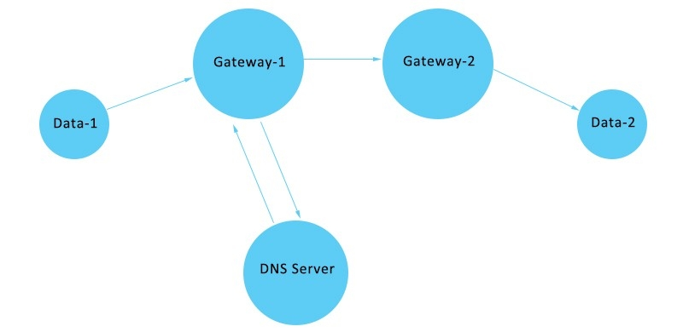

# **DNS**

An application layer protocol defines how the application processes running on different systems, pass the messages to each other.

* DNS stands for Domain Name System.
* DNS is a directory service that provides a mapping between the name of a host on the network and its numerical address.
* DNS is required for the functioning of the internet.
* Each node in a tree has a domain name, and a full domain name is a sequence of symbols specified by dots.
* DNS is a service that translates the domain name into IP addresses. This allows the users of networks to utilize user-friendly names when looking for other hosts instead of remembering the IP addresses.
* For example, suppose the FTP site at EduSoft had an IP address of 132.147.165.50, most people would reach this site by specifying ftp.EduSoft.com. Therefore, the domain name is more reliable than IP address.